Multifractal DCCA: GBPUSD and EURGBP
Method 24 / daily log returns / non-overlapping MF-DCCA / Alpari D1 full available history

Study setup
Logical pair: GBPUSD , EURGBP
Broker symbols: GBPUSD_i , EURGBP_i
Snapshot: 2026-11-03_majors_alpari_D1
Timeframe: D1
Matched return window: 1999-01-06 to 2026-11-02 (UTC bar dates)
Matched return count n: 7199
Dropped unfinished last bar dated 2026-11-03 UTC after a tick-volume check against the prior complete day.
Scales s in [20, 60, 100]; q in [2.0, 4.0]; headline q=2, s=100
Trend degree=1; overlap=none; positive q only
Complete matched rows (Excel): GBPUSD-EURGBP_MFDCCA_D1.xlsx
Complete matched rows (HTML table): GBPUSD-EURGBP_MFDCCA_D1_data.html

Method carried forward
Multifractal DCCA rho_q(s) extends detrended cross-correlation with a positive order q that weights large local fluctuations more strongly. Matched daily log returns of close, ln(close_t / close_t-1), are demeaned and cumulated into profiles. Non-overlapping windows of length s receive a degree-1 local detrend. In each window v, c_xy,v = mean(X_tilde * Y_tilde), c_xx,v = mean(X_tilde^2), c_yy,v = mean(Y_tilde^2). Then G(q,s) = mean_v[ sign(c) * |c|^(q/2) ] and rho_q(s) = G_xy / sqrt(G_xx * G_yy). Positive q only; q=2 recovers the DCCA-type average of c_v. Scales s in {20, 60, 100}; q in {2, 4}; headline q=2, s=100. Same-sample Pearson r is a side check only. This is not causation and not a trading signal.

Results (headline)
rho_q(q=2,s=100): -0.342743
rho_q(q=4,s=100): -0.224556
rho_q(q=2,s=20): -0.409455
rho_q(q=2,s=60): -0.403591
Pearson r: -0.397845

Scale / q summary
q | s | rho_q | n_windows
2 | 20 | -0.4094547 | 359
4 | 20 | -0.49322845 | 359
2 | 60 | -0.40359141 | 119
4 | 60 | -0.38329977 | 119
2 | 100 | -0.34274334 | 71
4 | 100 | -0.22455629 | 71

Conclusion
Headline rho_q(q=2,s=100) for GBPUSD and EURGBP: -0.3427. At q=4,s=100: -0.2246. At q=2,s=20: -0.4095; q=2,s=60: -0.4036. Pearson r = -0.3978. This is q-weighted detrended linkage, not a trading signal.

Charts
Daily closes

Daily log returns

rho_q versus s
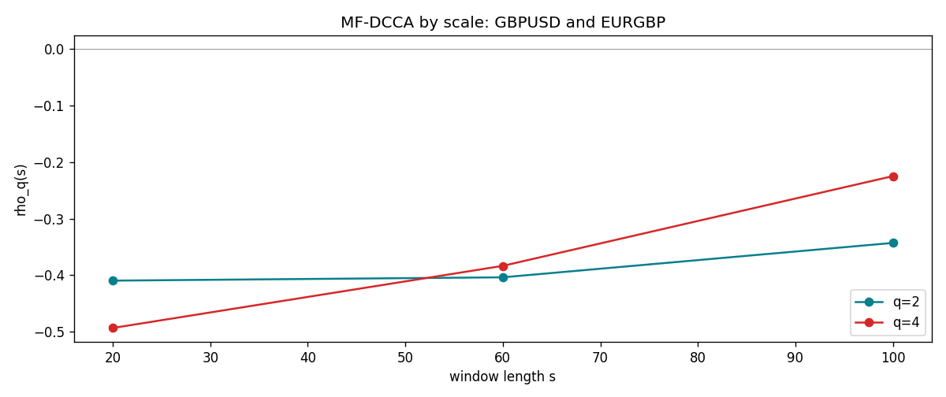

Data report
Matched rows and the scale sheet are in the sibling Excel workbook named GBPUSD-EURGBP_MFDCCA_D1.xlsx. Embedding all rows as a Word table is impractical; this file holds column summaries and the first and last 15 matched rows.
Columns: time, GBPUSD_open, EURGBP_open, GBPUSD_high, EURGBP_high, GBPUSD_low, EURGBP_low, GBPUSD_close, EURGBP_close, GBPUSD_tick_volume, EURGBP_tick_volume, GBPUSD_spread, EURGBP_spread, GBPUSD_real_volume, EURGBP_real_volume, GBPUSD_log_return, EURGBP_log_return
Column summaries (matched calculation rows)
column | count | mean | std | min | 25% | 50% | 75% | max
GBPUSD_open | 7199 | 1.5160931 | 0.21831499 | 1.06854 | 1.324955 | 1.5114 | 1.63186 | 2.1066
EURGBP_open | 7199 | 0.78665041 | 0.09676322 | 0.5734 | 0.6873 | 0.83367 | 0.865175 | 0.9769
GBPUSD_high | 7199 | 1.5223838 | 0.21887686 | 1.08366 | 1.32978 | 1.5181 | 1.6384 | 2.1161
EURGBP_high | 7199 | 0.78972718 | 0.09713886 | 0.5789 | 0.68935 | 0.83657 | 0.86804 | 0.9799
GBPUSD_low | 7199 | 1.5097628 | 0.21753729 | 1.03518 | 1.3194 | 1.50323 | 1.62442 | 2.0983
EURGBP_low | 7199 | 0.78395066 | 0.09658082 | 0.5682 | 0.6853 | 0.83147 | 0.862765 | 0.9661
GBPUSD_close | 7199 | 1.5161471 | 0.21826306 | 1.06879 | 1.325055 | 1.51122 | 1.63216 | 2.1065
EURGBP_close | 7199 | 0.78669405 | 0.09676312 | 0.5735 | 0.6875 | 0.8337 | 0.86528 | 0.977
GBPUSD_tick_volume | 7199 | 94850.986 | 153561.38 | 62 | 9998.5 | 52911 | 91818.5 | 1273370
EURGBP_tick_volume | 7199 | 86949.029 | 145390.09 | 154 | 6517.5 | 44265 | 81326 | 1424684
GBPUSD_spread | 7199 | 26.96055 | 19.19062 | 0 | 11 | 20 | 50 | 50
EURGBP_spread | 7199 | 21.393666 | 19.14328 | 0 | 4 | 13 | 50 | 50
GBPUSD_real_volume | 7199 | 3.5570778e+09 | 8.4449923e+10 | 0 | 0 | 0 | 0 | 2.4038164e+12
EURGBP_real_volume | 7199 | 2.7805214e+10 | 1.3507095e+11 | 0 | 0 | 0 | 0 | 3.5726265e+12
GBPUSD_log_return | 7199 | -3.133e-05 | 0.00564236 | -0.08388241 | -0.00313644 | 2.978e-05 | 0.00317207 | 0.03112653
EURGBP_log_return | 7199 | 2.179e-05 | 0.00487166 | -0.03067367 | -0.0026225 | -0.00010035 | 0.00256076 | 0.06075387
First 15 matched rows (selected columns)
time | GBPUSD_log_return | EURGBP_log_return
1999-01-06 | -0.00060452184 | -0.013303338
1999-01-07 | -0.002118709 | 0.011051402
1999-01-08 | -0.0058954193 | -0.004943862
1999-01-11 | -0.0056851331 | -0.0012752393
1999-01-12 | 0.0022657001 | 0.0033970309
1999-01-13 | 0.0091330396 | 0.00042381861
1999-01-14 | 0.0019376331 | -0.0019793588
1999-01-15 | -0.0017558204 | -0.0076715819
1999-01-18 | 0.0012112405 | 0.00071280921
1999-01-19 | 0.0018745281 | -0.0014261269
1999-01-20 | -0.0049053846 | 0.0019960086
1999-01-21 | 0.0031518998 | -0.00071240297
1999-01-22 | 0.0024781662 | -0.0017118406
1999-01-25 | 0.0012066366 | -0.0054402425
1999-01-26 | 0.00072328374 | -0.00057438255
Last 15 matched rows (selected columns)
time | GBPUSD_log_return | EURGBP_log_return
2026-10-13 | 0.0036434319 | 0.00020130374
2026-10-14 | -0.0049164679 | 0.0011241873
2026-10-15 | 0.0065976411 | -0.00087557391
2026-10-16 | 0.0037592051 | -0.0020380844
2026-10-19 | -0.0017500314 | -0.00056950988
2026-10-20 | 0.0055923442 | -0.0035906254
2026-10-21 | 0.0012476328 | -0.00140647
2026-10-22 | 0.00022396082 | -0.0018743924
2026-10-23 | -0.0021146949 | 0.00082421033
2026-10-26 | -0.0024340661 | 0.00013133309
2026-10-27 | -0.0023648393 | -0.0019957343
2026-10-28 | 0.0015771808 | 0.00066967224
2026-10-29 | 0.0035881935 | -0.0011722209
2026-10-30 | 0.0013450605 | -0.0024205543
2026-11-02 | 0.0010971256 | 0.00089940465

